Chapter 12, Solution 67.

- The power to the motor is

The motor power per phase is
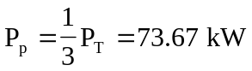

Hence, the wattmeter readings are as follows:
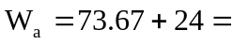
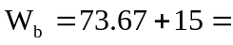
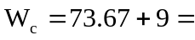 82.67 kW

- The motor load is balanced so that 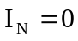.
For the lighting loads,
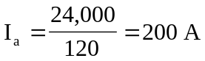
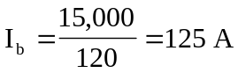
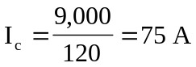

If we let
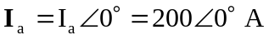
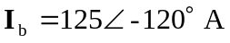
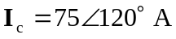
Then,
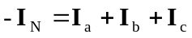
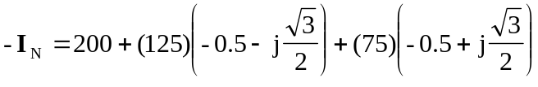
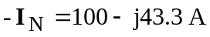
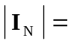 108.97 A

